|  |  |
| --- | --- |
|  | Additional Information |

This notice includes information related to your rosco_m68k Classic v2 product. Please read this sheet carefully and retain for your reference.

1. USB Connection

**Your rosco_m68k is equipped with a USB-C connector which can provide both power and dual-serial port capability via a built-in USB-to-serial converter.**

Linux® and macOS® users should see two ports autodetected when connecting the rosco-m68k, which can then be opened as normal in your serial program.

Windows® users may need to install additional drivers (for the “Virtual COM port”) – these can be downloaded here: <https://ftdichip.com/drivers/vcp-drivers/>

Since the rosco_m68k requires more than 500mA current, some (likely older) USB hosts may refuse to provide power to it (for example, when using a USB-A to USB-C cable) – in this case, we recommend using a powered USB hub the connection.

**Since USB is now the preferred power and communication solution for the rosco_m68k, we do not supply as standard the various pin headers and jumpers required for the legacy connections.**

2. 8 and 16-pin Sockets

We do not supply sockets for the 555 timer or the 74HCT148 interrupt encoder – the intention is that these commodity ICs be soldered directly to the board – once fitted they will not need to be removed.

3. CPU Socket

Instead of a single 2x32 pin socket for the CPU, your kit contains 2x 32 pin SIP sockets, which are used to create a socket for your CPU.

To ensure alignment when fitting these, we recommend they are first fitted to the CPU, and them mounted into the board (you will need to bend the pins slightly).

Once fitted, you can lightly solder three pins on each side (one at either end and one in the middle) before removing the CPU and completing the soldering of the sockets.

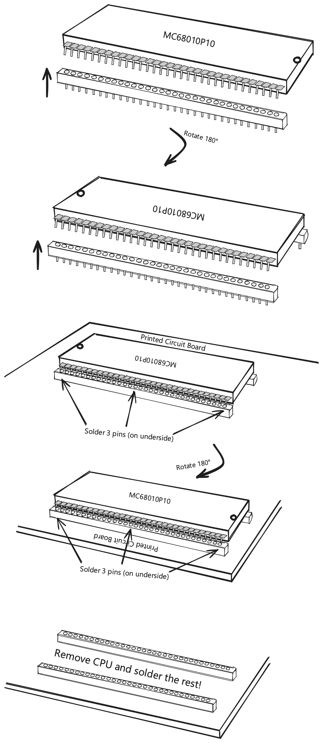

4. JP1/JP2 Jumper Setting (Legacy connection)

**JP1 & JP2 are optional jumpers that allow the board to receive power via the FTDI module. Only one of these jumpers should be shorted at any given time, and it must only be shorted when the board is powered via the module. Connecting this jumper when external power is also connected, or shorting both jumpers at once, may damage your rosco_m68k, your FTDI module(s), power supply and any connected equipment.**

Additionally, when powering the board via an FTDI module, you must ensure that the current requirements (No less than 500mA for the main board alone) are met. Where your computer or FTDI module are unable to supply the minimum current requirement, improper operation and (in rare cases) permanent damage may occur.

5. JP3 Jumper Setting

When shorted, JP3 is a hardware-enable for writing to the Flash ROMs. With this jumper shorted, special software (e.g., the firmware flash utility) will be able to write the ROMs and update your flash.

Although software write prevention measures are also in place to prevent accidental writes, leaving this jumper open may give additional peace of mind that writes cannot occur.

6. JP4 Jumper Setting

When shorted, JP4 changes the behaviour of the mainboard with respect to expansion RAM space. This jumper is only needed where the board is to be used with an original rosco_m68k memory expansion board, and should be left open in all other configurations.

7. JP5 – JP8 Setting

**These jumpers allow the UART pin headers to be used, instead of the USB connection.**

Cutting JP5 and JP6 will disable USB connection on UART A. This is an advanced configuration and should not be needed by most users.

Cutting JP6 and JP7 will disable USB connection on UART B. **This will be required if you are using e.g. the rosco_m68k® Keyboard with your main board.**

The jumpers have a small track between the two pads by default – to disable USB you need to use a craft knife or similar to cut that small track.

**Care should be exercised when cutting these tracks to ensure the board is not damaged by cutting too far, or too deep.**

8. SD Card Connection

**The SPI SD Card header provided on the board is 5V and will require an Arduino-compatible SD card adapter with level 5V<->3V3 conversion in order to operate. These are commonly available, and the pinout of the connected is designed to match them.**

Attempting to use an SD card without an adapter, or with and adapter that does not have built-in level conversion, is likely to damage or destroy your SD card (and in rare cases may also damage your main board and connected peripherals).

9. Compliance Notices

**All information contained in the product documentation (herein and online) and any additional information and documentation (including this notice) is correct as far as possible at the time of writing. Errors & omissions exempt.**

To achieve compliance with local regulations regarding electro-magnetic interference (both transmission and receipt) the product may need to be operated in a suitable grounded enclosure with appropriate application-specific shielding. The Really Old-School Company Limited neither specify not supply such enclosures and recommend that expert guidance be sought where an enclosure is to be used.

The Really Old-School Company Limited does not authorize the use of any of its products in safety critical or life support applications where the failure or malfunction of the product can reasonably be expected to cause failure of the safety critical or life support system or to significantly affect its safety or effectiveness. This includes, but is not limited to, human life support, nuclear safety and control, air-traffic control, and vehicular control.

**Products are not authorized for use in such applications under any circumstances.**

All PCBs and components (other than the MC68010) we supply are compliant with Restriction of Hazardous Substances in Electrical and Electronic Equipment (RoHS) regulations.

Legacy ICs (the CPU) may not be compliant with the modern regulation, and it is not feasible to make them so.

Compliance in finished kits you build will also depend on your choice of solder when building your board.

Please dispose of any waste in accordance with relevant Waste Electrical and Electronic Equipment recycling (WEEE) regulations in your jurisdiction.